**Practice Test 4**

**ReCo**

Earthquakes are a natural occurrence and they happen all over the world. Although earthquakes may happen randomly, it is important to understand that there are certain factors that can increase the likehood of an earthquake happening. An earthquake occurs when two part of Earth’s crust sh~~ock~~/ift relative to each other. This movement causes stresses within the crust which cause it to facture and break along existing fault lines.

**ReSe**

Highlight register inteval confirm distribute substantial implement quality define majority

**LiTy**

They had~~ve~~ to changed their schedule because the train arrived late.

**ReAl**

His joke made everyone in the room laugh.

**WrPho**

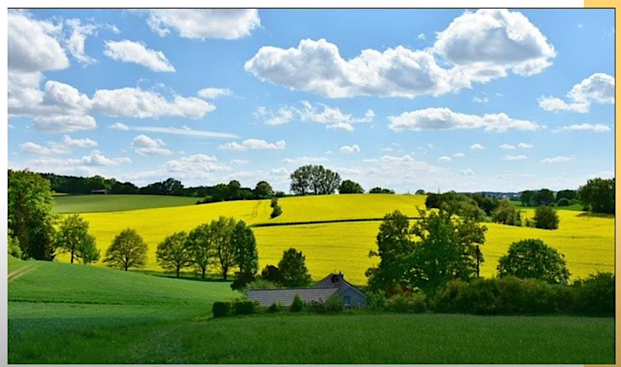

I can see the opened scence with yellow and green grass, also some small trees.

The sky is almost clear with some white clouds flying. The cloulds are exciting with many imagable shapes.

In this photo, a quaint house is tucked into a lush field. Even though the fields consist mostly of grass, trees and shrubs are scattered around. It is likely a summer day with light clouds dotting a clear blue sky.

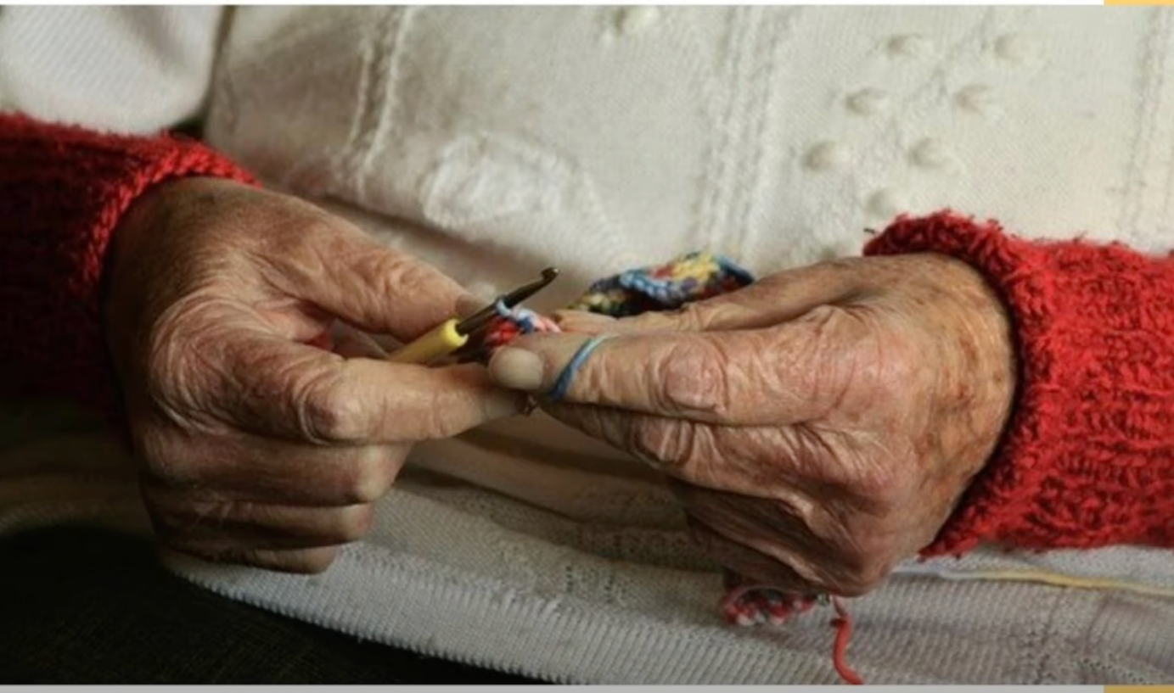

In this photo, it is seem to be that a old woman is sewing somethings. She weared a white shirt with red color on the hands. She may making a small bag. The bag will be colorful. Her hands are yellow and show the sign of time.

This photo shows an elderly person crocheting multicolored yarn. The person is wearing a thick white and red sweatshirt. As she has just started her project, it is unclear what exactly it is she is creating.

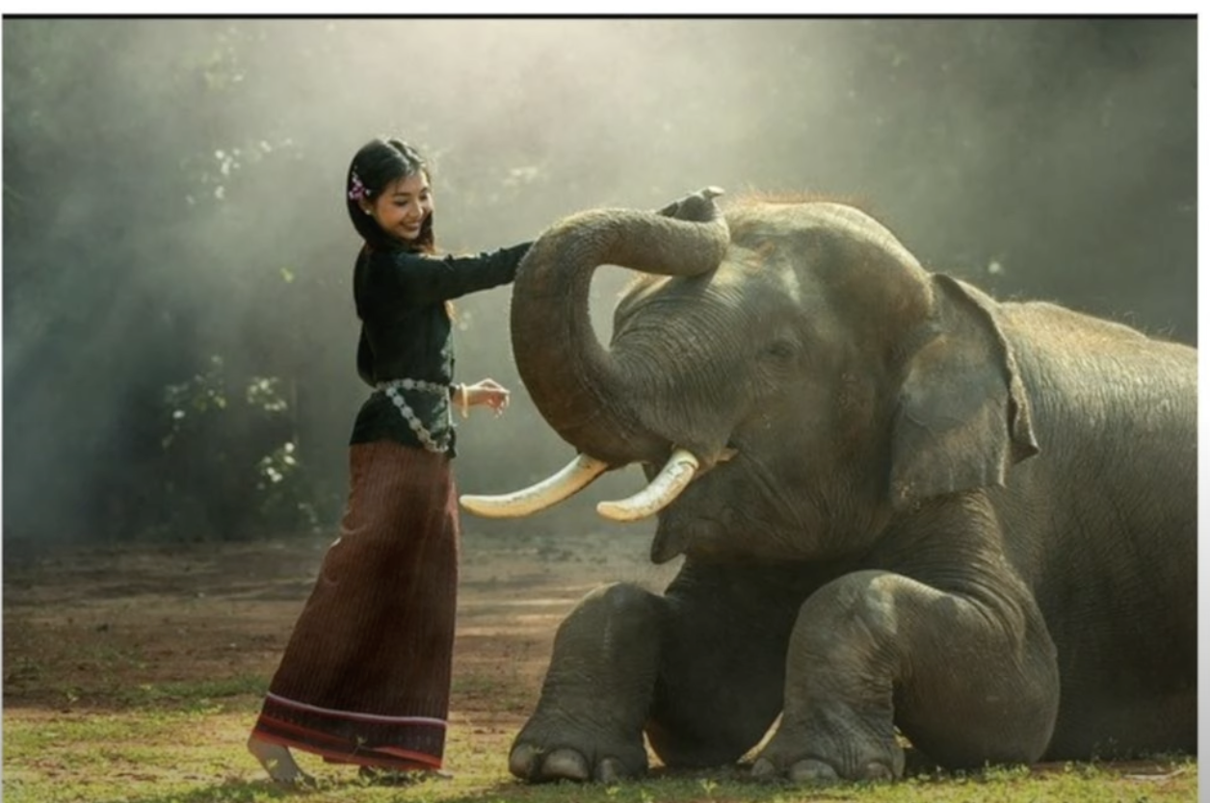

I can see a magical scence on the above photo. A young girl is touching on the nose of black elephant with happy smile. She is wearing a black unique form with brown skirt that belongs to her village. A light is shining all that makes the luxury picture.

The image shows a young girl playing with an elephant. Both the girl and the elephant look relaxed **suggesting** they are familiar with each other. The girl’s hair is black with a purple flower tucked behind **her ear**.

**LiTy**

You can never be too careful ~~in~~ when driving.

**ReCo**

Meditation is a powerful self-improvement tool. Practicing meditation helps to cultivate mindfulness, promoting mental clarity and reducing stress. It can enhance our concentration skills and improvement emotional health. Meditation also fosters self-awareness, allowing us to better understand our emotion**s** and thought patt**erns**. By practicing regular meditation, we can achive a more balanced and tranquil state of mind.

**ReSe**

Modest Temperature document simplify export element structure consistent underestimate

**ReCo**

Practicing spoken English is crucial for improvement. Speaking English in ever**yday** situations helps increase fluency and confidence. One c**an** practice speaking English with friends at work, or even use language exchange platforms. Engaging in English conver**sa**tions helps to apply the vocabulary and grammar rules learned, making the laguage second nature.

**ReAl**

We had no advanced warning that this was going to happen.

**ReSe**

~~Afflusion transquilate~~ Enhance ~~hibrance~~ orientation proximity professional predict

**LiTy**

If you need any assistan~~t~~ce, please ~~can~~ get help ~~in a~~ from the general office.

**ReAl**

I am a little nervous about giving this presentation.

I am a little nervous about giving this presentation.

**Interactive Reading**

When I first enrolled at Maplewood Elementary, it was just another building with classrooms and a playground. But as the years passed, something incredible began to unfold in our community. My school began to evolve beyond its ~~common~~ standard edicational purpose. One evening, as I headed home after soccer practice, I noticed our art room lit up and alove with local artists hosting a workshop. The next week, my moom mentioned attending a book club in the school library. By Saturday, our school’s auditorium had ~~moved~~ transformed, screening films made by our town’s budding filmmakers. Over time, Maplewood wasn’t just my school anymore.

**CoPa**

…

Every corner of the campus whispered strories of connections, newfound talents, and shared learning. My school had truly become more than just a place for lessons; it was where our community found its soul.

It had become a heartbeat of our community, bringing together people of all ages and intersts.

**HiAn**

(Yellow parts in copa)

**IdId**

4

**TiPa**

Beyond Classrooms: Maplewood Elementary’s Community Evolution.

**Interactive Listening**

~~Hi there, Professor. May I have a moment to discuss a personal issue regarding my accommodation?~~

You: Hi Professor. I’m here for our meeting.

Professor: Come in. ~~So,~~ You said you wanted to meet me about schoolarships ~~can go and seat~~. How can I help you?

You: To be honest, I’m not sure where to start, and I was wondering if you had any tips or suggestions.

Professor:

You: Sure I definitely help with that, have you ~~have~~ looked into any specific schoolarships that you are interested in ~~year for student~~?

~~Yes, and I have found that a lot of people enjoy it~~.

Professor: Not yet, I wasn’t sure where to begin my search.

~~Well, a good way to restart to research schoolarships that relevant the field of study or activity or~~

You: Well, a good place to start would be to research schoolarships that are relavant to your field of study or extracurricular activities. You can also check with your department or school to see if they have any schoolarships or awards available.

Professor: Ok, I’ll do some research. Do you have any advice for how to make my application stand out?

~~There is an important paper that I need to prepare for. I’ll email you later.~~

You: Okay, I’ll definitely keep that in mind. Thank you for your help, Professor.

**SuCo**

I asked my professor for tips and advice on starting my schoolarship search. She suggested researching relevant schoolarships and emphasizing my unique characteristics in my application. I said thank you and that I’d keep her ideas in mind.

**SpPh**

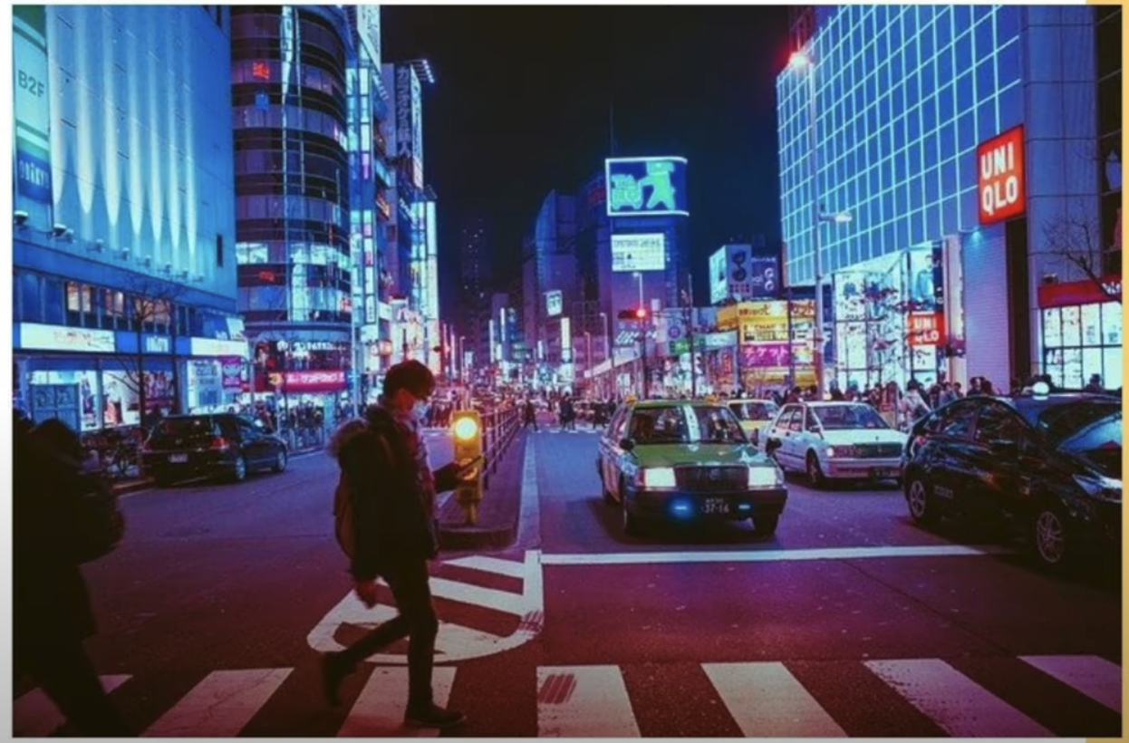

The picture shows the street at night. There are a man walking across the road and some cars running. And also, the are many high building at 2 sides of the road. All the building are lighted with neon.

This photo shows a bustling are of a major metropolis filled with people, cars, and buildings. The cars must be waiting at a red light because a couple of people, including a man who is casually texting someone, are crossing the sreet along the crosswalk. This is a two-way street with a pair of lanes on either side of the median which divides the traffic. All the buildings emanate a futuristic blue light that pairs well with the red signs hanging from their facades. Atop a tall building in the center is a gigantic blue sign that brightds up the street. It is clearly night as the sky is pitch black and the cars have thir headlights turned on. The street stretches straight back for many blocks with at least two crossroads for pedestrians to use when crossing.

ReSp

I want to share my experimence in making the changes to help my team to cowork more smoothly, that help to feel more excited than at home. The first is making more discussions that relating to our concerns or our jobs. The second is organizing team work activities which should be held outside, too. This help each person can show their abilities in many situations, this thing helps understand more clearly about each other.

To do these setups, the best way is setting a rotating meeting, when each people can see or look at each other. The leader should emphasizing the highlight target the final goal for these setups or activities.

Our team has 10 people, that helps us work perfectly and we have achived some amazing projects like that way.

So, when I think of offices, I don’t just see them as these dull places where you clock in and out. I mean, why can’t they be as fun as they are productive? Imagine walking into an office with bright colors, comfy couches, maybe even a ping pong table in the corner! It’d feel less like a workspace and more like a cool lounge. And you know, teamwork is supper important. So, what if we has spaces designed just for brainstorming? Like, cozy circles of chairs, whiteboards everywhere and tech stuff for virtual team members to join in. That would be awesome! But making it feel like home? Maybe let people bring in personal stuff – their favorite mug, some family photos, or even their plants. It makes a huge difference when you have a personal touch around. Now, figuring oyt what’s bestm that’s the trick. I reckon, start by asking people what they want. Maybe rearrange things every month, see what setups get people chatting more, or just looking happier. I would suggest conduction little experiments and getting lots of feedback. If a boss would do that, then they’d be able to create a dream office for their employees.

**LiSp**

Tell about something that you bought that was difficult to use at first, where did you buy it, what does it do? Why was it difficult to use at first?

The first macbook that I bought 4 years ago seem to be the computer that was difficult to use. Apple introduced it with M1 processor, that a very powerful CPU incomparing with Intel’s one that time. The Ui of Macos is definitly strange for me because I was familiar with Windows OS. I used Windows OS from the first time I used computer at home or at office. I bought it from the agency of Apple, the first official brand in Vietnam. But I spent 1 week to find out the video that introducing about macos and also its Ui. Then I practiced them on my M1 macbook air. My macbook made me so supprized because of its speed, its smart functions that helped us finished all my simulating or degisning tasks faster, more effectively. It was the worthy decision for me.

For the longest time, I bought and used Microsoft and Google products. But one summer, after hearing so many good things about Apple products, I finally decided to buy a Macbook. I hoped I would be able to use it right away, but it wasn’t as easy as I’d hoped. A lot of things I’d learned on PCs didn’t work at all on my new computer. The layout was different, and even some of the keyboard shortcuts I had grown accustomed to be found. It felt like learining a new language at first. So I searched the internet and found a few handy guides that explained how to use it. The biggest chang I had to get used to was navigating the menus. Then I had to adjust to the mouse pad and the pinching movements you can do. It tool some getting used to, but in the end, it was a challenge worth facing.

For the longest tire I bought and used Microsoft and Google products but once summer answer to hearing so many good things about Apple products I finally decided to buy a MacBook. I hope OT able to eat right away, but it wasn’t as easy as I’d hope it a lot of things I would learn on pieces didn’t work at all on my new computer. The layout were different and even some keyboard sus I had grown to wear now here to be f, it felt like learning a new language at first show I search the Internet and file a few handy guys that explained how to eat with chain I had to get to war navigating the menus. I had to adjust to the pass and the pitching movements you can do it took some getting uses, but in the end, it was a child was fighting.

**ReWr**

Some children spend a lot of time in classes and planned activities. Why is it important for children to have free time? Give specific reasons for your answer.

More and more, societies around the world have started to see the value of free time for children. First and foremost, freedom to do what they want helps them discover their identity. If I had always focused on school homework, my current interests and hobbies might not have developed. Secondly, being free to do our own activities helps us relax. Shooting basketball for an hour each evening helps me manage my stress, and I only discovered this activity because of my free time. In conclusion, the freedom for children to choose how to spend their time is essential for them to explore who they are.

**Sp**

Talk about a person you know who inspires you. Who is this person? How do you know this person? Why does this person inspire you?

You know, if I had to pick the one person who’s really made a mark on my life, it’d hands down be my grandma. She’s taught me so much – from those personal life lessons like being patient and kind, to really getting me into our culture and arts. Every time I think about it, I’ve just always wanted to be a bit more like her. Grandma’s got this whole list of really cool and unique qualities. One of her qualities that really sticks out is that she’s super warm-hearted and just loves life and people. I swear, almost everyone adores her. Though, of course, she’s had a couple of arguments, like all of us. But, overall almost everyone I know loves her. Another truly amazing thing is that back in the day, she was all about promoting our local arts and culture. She was the go-to person for community events and cultural stuff, and she’d even throw in free workshops on some weekends. Because of her, I’m totally into arts now and want to spread our culture far and wide. To sum ot up, grandma’s been my rock, and all I wanna do is make her proud.

**Wr**

Describe a time when you made a mistake, but you learned something important. What happened? What did you learn? Include specific details in your answer

Making mistakes is an routine part of life that always provides a valuable lesson. I recall a mistake I made about ten years ago after breaking my leg. In the beginning, my recovery went smoothly as I tool great care to do exactly what the doctor asked of me. However, after a few months, I started to become impatient and decided to test it out through exercising more than recommended. As a result, my leg did not heal properly, and it still bothers me today. In the end, I learned the importance of following a doctor’s recommendation over my own misguided desire.

**Full test 5**

An antibiotic is a chemical compound that kills bacteria or slows their growth. They are used as medicine to treate and cure diseases caused bby bacteria. The first antibiotic discovered was Penicillin, a natural antibiotic product by a fungus. Production of antibotics first began in 1939, and in the modern day, they are made by chemical systhesis. Antibiotics can not be used to treat viruses.